**Name:** Marco Hidalgo Romero

Assignment 2

**Deadline: Check the calendar of your course shell**

# Learning Objectives

The learning objectives of this assignment are:

Learning the procedure of Comprative Analysis Creating the high ﬁdelity prototype for your application

# Assignment Steps

## P1) Procedure of Competitive Analysis (50%)

Competitor analysis in marketing and strategic management is an assessment of the strengths and weaknesses of current and potential competitors. This analysis provides both an offensive and defensive strategic context to identify opportunities and threats. Proﬁling combines all of the relevant sources of competitor analysis into one framework in the support of efﬁcient and effective strategy formulation, implementation, monitoring and adjustment [[1](http://assets.csom.umn.edu/assets/71542.pdf)].

In the ﬁrst assignment, you provided similar applications to what you are going to develop. Regardless what you are developing, it is always possible to ﬁnd the applications with similar themes. In this part, you need to compare your application with competitors in a matrix.

### Please write the name top ﬁve competitor apps.

### COVID Alert

### Canada COVID-19

### COVID Alert NY

### COVID Alert NJ

### COVID Alert PA

Use their products/services to understand how their business is structured.

### COVID Alert

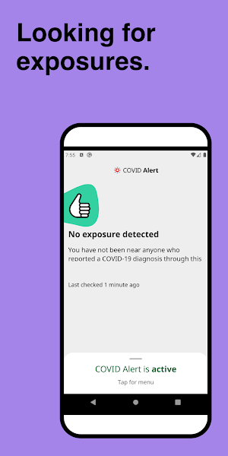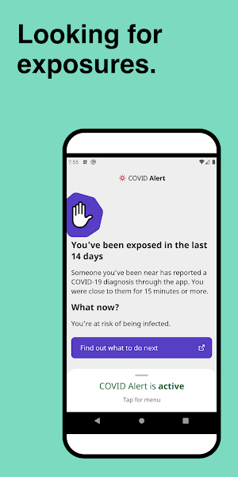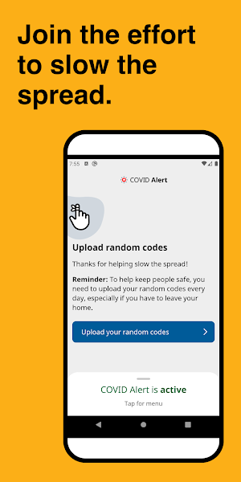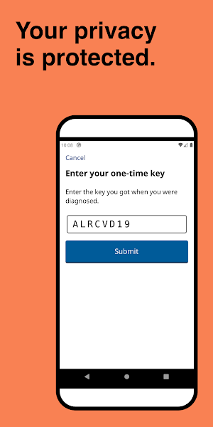

### Canada COVID-19

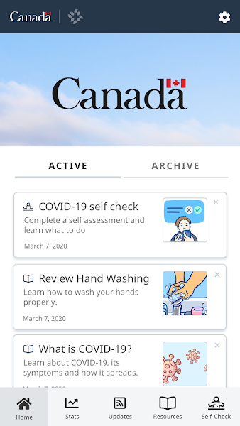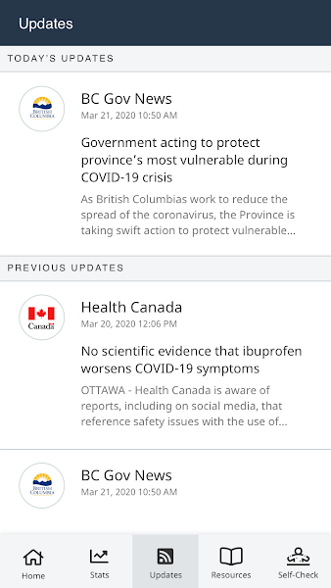

### COVID Alert NY

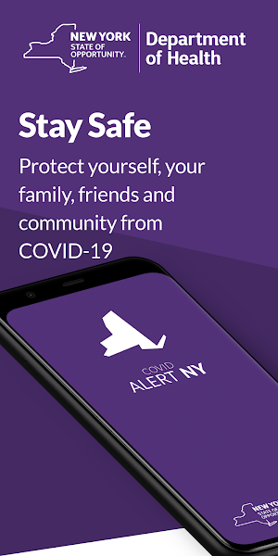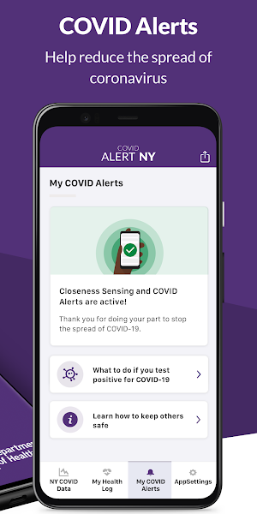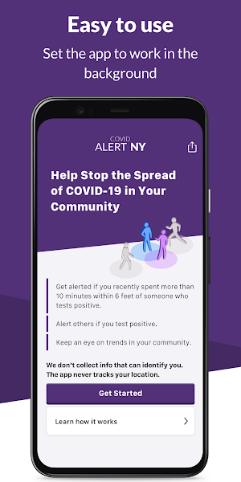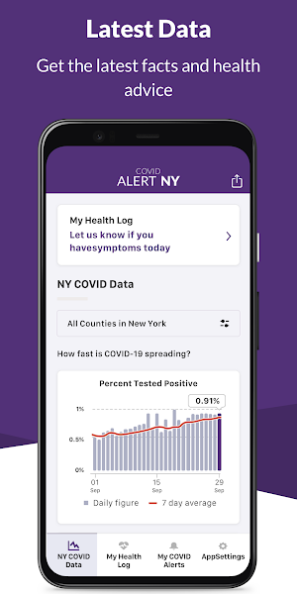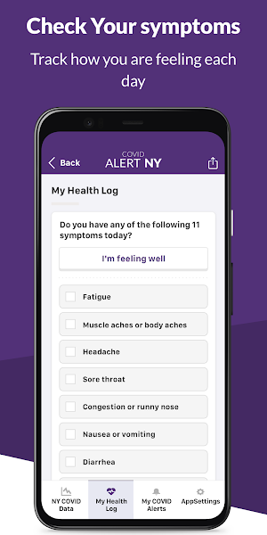

### COVID Alert NJ

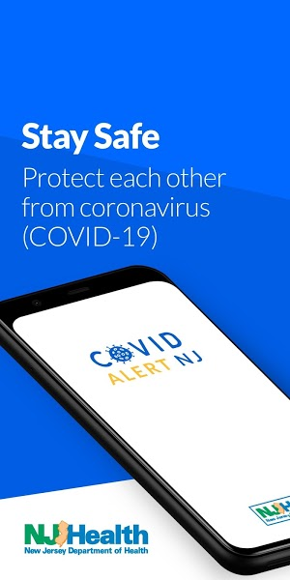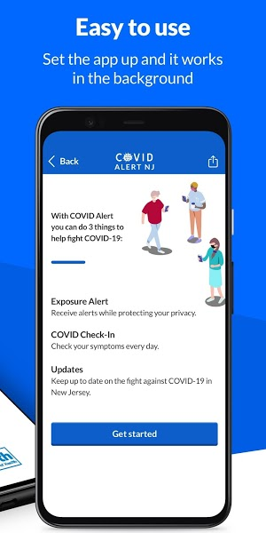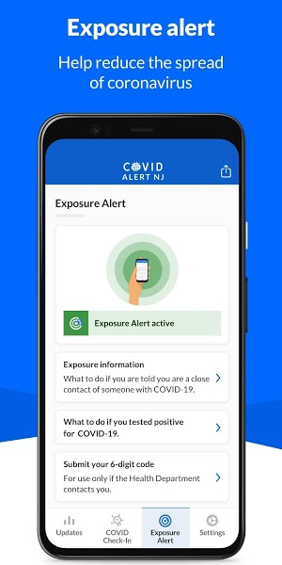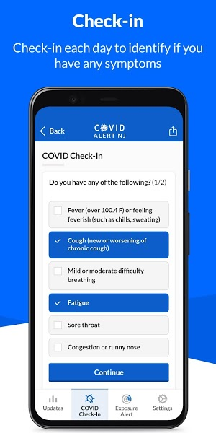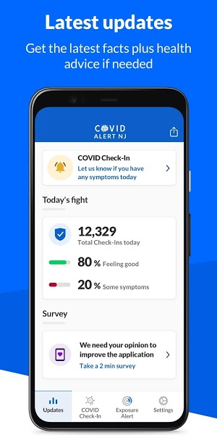

### COVID Alert PA

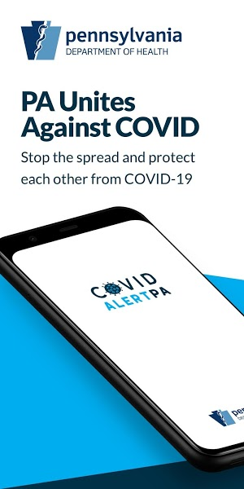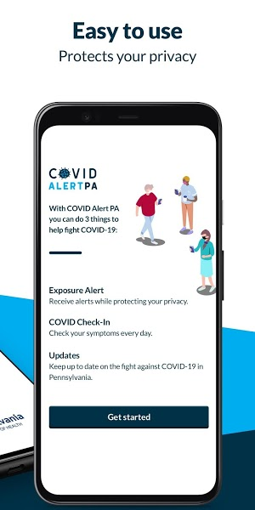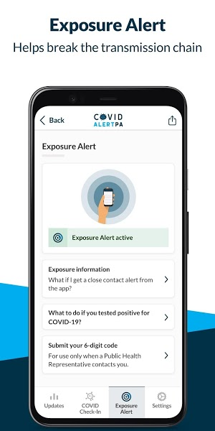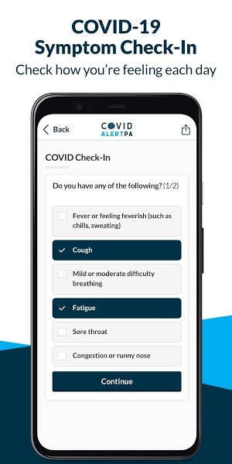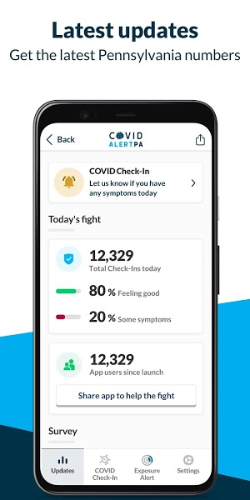

Study [**"A Product Designer's Guide to Competitive Analysis"**](https://tofighi.github.io/courses/hci/CompetitiveAnalysis.pdf) article and based on the given guidelines **draw the Competitor Analysis Matrix** while one of the columns is dedicated to your product. A typical competitor analysis matrix contains the following (yours should at least contain them as well):

1. Features/solutions of the platform you are building.
2. Conﬁrmation that the competitors have/don’t have the same feature/solution.
3. Score — you can assign a certain number of points to each of the features based on their importance. For example, in the sample above, chat may carry 10 points and stories may carry 5 points. Add all the points together and divide by the number of features = competitor score in percentage. The visual design, overall user experience, and performance of each of the platforms you analyzed may also be included.

Competitor Analysis Matrix drawn in attached Excel spreadsheet.

Identify any UX/HCI issues with a competitor’s product and **create a comprehensive list of UX/HCI issues of your competitors here**. This list will help you learn from other people’s mistakes. After identifying UX issues, look for any visual design shortcomings. For example, how well are the calls to action designed and what kind of color palette are they using? This will help you design a better visual experience for

your product.

**Hint:** To ﬁnd common UX/HCI issues, more than the main article,search for them. For [example, you can ﬁnd articles such as 9 Usability Issues that Plague Today’s Mobile Apps or](https://blog.appsee.com/9-usability-issues-that-plague-mobile-apps/) [19 common UX problems and how to ﬁx them](https://www.creativebloq.com/ux/problems-81412676)[.](https://blog.appsee.com/9-usability-issues-that-plague-mobile-apps/)

* Too many taps
* Disregarding landscape mode
* Turning a blind eye on OS versions
* No auto-filled customer data (only Canada COVID-19 has this feature)
* Deep navigation (only COVID alert does not seem to have this issue)

Identify any UX issues with **your initial prototype you created** in the ﬁrst assignment and create a list of UX/HCI issues of your prototype here

* Too many taps
* Disregarding landscape mode
* Turning a blind eye on OS versions
* No auto-filled customer data
* Deep navigation

## P2) Your second prototype using Figma(25%)

Study [**Perfect Your UX Design Process – A Guide to Prototype Design**](https://tofighi.github.io/courses/hci/PrototypeDesign.pdf) to learn about steps of creating a better prototype. Choose the best ideas of your ﬁrst design and remove the issues you made in ﬁrst design.

### Provide screenshots of your ﬁnal design which contains all the features of the app you are designing.

### Screenshots provided on attached PDF.

1. **Provide a public URL of your Figma design.** The prototype should be workable (clicking on the menus, icons,etc should show the interface or move to the next screen)

<https://www.figma.com/file/1FPC4Za4zYbykC6suuh1Bm/My-COVID-19-App-Copy?node-id=0%3A1>

1. Create a video of interactions with audio narration, and upload to YouTube (Or upload on Slate/OneDrive if you have privacy concerns). Go through all the screens and talk about what app is capble of. You can watch [this video](https://www.youtube.com/watch?v=W8qRG6I26C0) to see how to record it or simply use [OBS](https://obsproject.com/). Provide the

URL of video in the document.

Video uploaded to SLATE Dropbox and GitHub repository.

## P3) GitHub and new features (25%)

Create a GitHub repository and upload your ﬁgma ﬁle there and write a short description with some screenshots, public URL of your ﬁgma design, and your vide URL (if uploaded on YouTube) in README. Share the URL of GitHub in the document you submit for the assignment. Good GitHub repository and documentation and video preparations will receive **bonus marks** .

<https://github.com/marcohcanada/My-COVID-19-App.git>

Based of the process of Need Finding and Competitive Analysis, write top ﬁve **new** desirable functionlities (such as having the ability of helping people in need such as elderly people) in the COVID-19 app that you have not seen before in any other apps. Please add these to your README on GitHub.

1. **COVID-19 Case-Based Surveillance:** Enrolling and tracking suspected cases
2. **Contact Registration:** Strengthening active COVID-19 case detection through contact tracing activities such as identification
3. **Ports of Entry Screening:** Enrolling travellers who have visited COVID-19-high-risk locations for 14-day monitoring and followup
4. **COVID-19 Surveillance Event:** A simplified list that captures minimum necessary data points for daily or weekly reporting
5. **COVID-19 Aggregate Surveillance:** A reporting dataset that captures minimum necessary data points for daily or weekly reporting

**Optional** (but recommended): Share your GitHub URL in this page. This helps everyone in this course look at your design and we collaborate together to discuss about the prototypes

# Submission

This is an individual assignment

The deadline is based on what you see on the course shell.

You should submit a single PDF contaiting all three parts and a **ﬁg ﬁle** of your prototype

Late submission will receive 10% deductions per 24 hours up to 72 hours. After 72 hours, 0 will be assigned.